Inverter does not display battery voltage

Author:胡维
Reviewer：Eason

FAQ\BAT
Issue introduction
The inverter does not display the battery voltage when the battery relay is closed and the master battery status light is solid green.
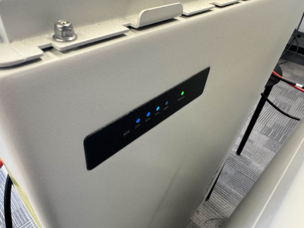 | 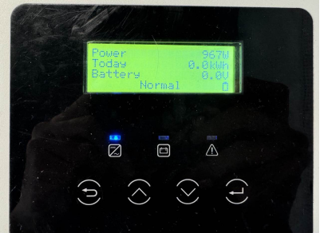
The master battery status light is solid green. | The inverter does not display the battery voltage.
Confirmation of basic information
1.[Photo]SN number of the inverter and battery.
Guidance for installer
Step1: Disconnect the battery and inverter, then black start the battery. After hearing the click sound of the battery, measuring the voltage of the battery as shown below.
For T58, according to the following rules, dial the DIP switch to the correct number of black start based on the actual number of batteries, then move the circuit breaker switch to “ON” and press the power button to black start the battery. Remember to short-circuit the last battery.
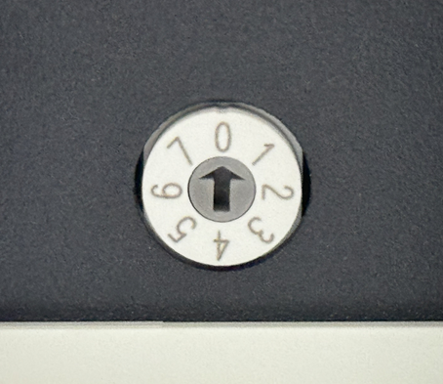
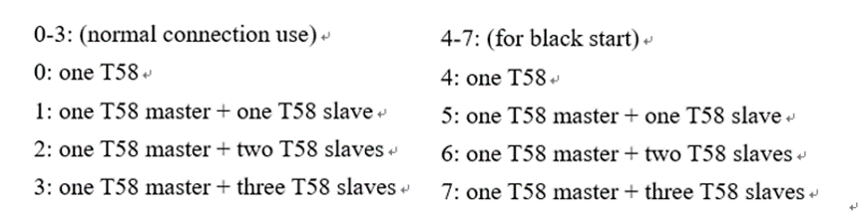
For T30, move the circuit breaker switch to “ON”, press the POWER button and hold it for 20 seconds, then release the button after the four SOC indicators flash blue alternately.
The battery will click when it starts successfully, if not, check whether the power cable between battery and battery are correctly connected.
After successfully black start the battery, measure the voltage of the battery as follows.
Measure the voltage of T58 | Measure the voltage of T30
Use the red pen and black pen of the multimeter to measure whether the voltage on the battery side is normal. Normal single T58 battery voltage, manual rated 115.2V, the operating voltage range of 100-131V or so.  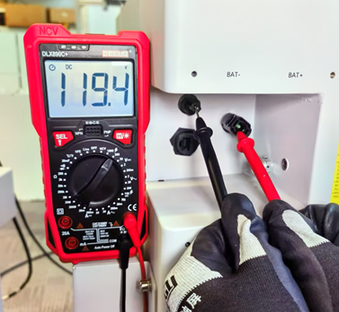 | Use the same method to measure the voltage of T30, and a normal T30 single battery has a rated voltage value of 102.4V and the operating voltage range of 90-116V.  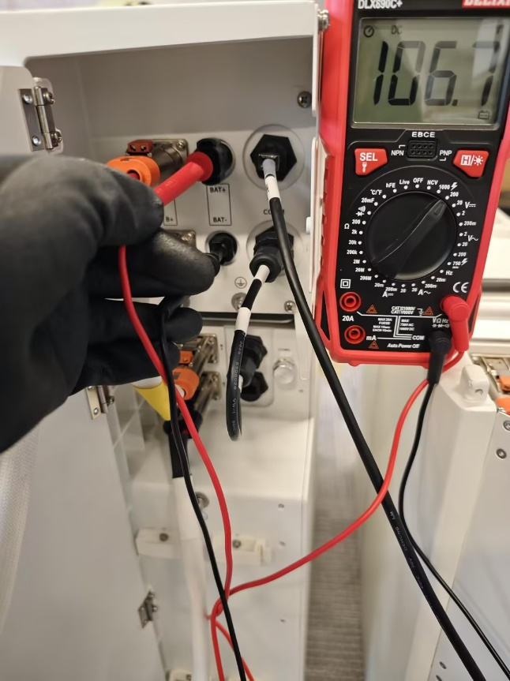
Step2: Connect the power cable between battery and inverter to the battery, and measure the voltage of two cables as shown below. Ensure the voltage is within the normal range of the battery voltage. If the voltage indication is abnormal, replace the power cable and try again.
Voltage of T58 battery Power cable | Voltage of T30 battery Power cable
Insert the red pen into the power cable of BAT+, and insert the black pen into the power cable of BAT-.  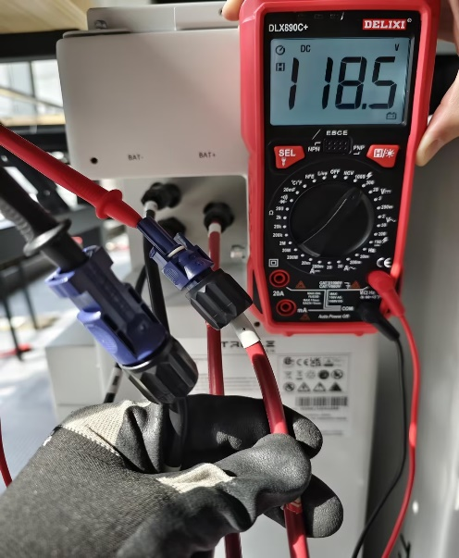 | Use the same method to measure the voltage of T30.  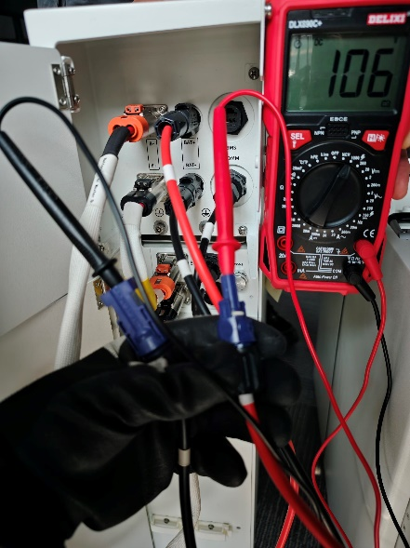
Step3: Upgrade the battery and inverter to the latest firmware version, correctly connect the cable from battery to inverter. Then start the battery and observe the battery voltage information on the screen.
Information check list
If you have completed the above <Guidance for installer>, and the problem is still not solved, please collect the following troubleshooting information and send them to the R&D.
1.[Photo]Inverter information including SN and registration number.
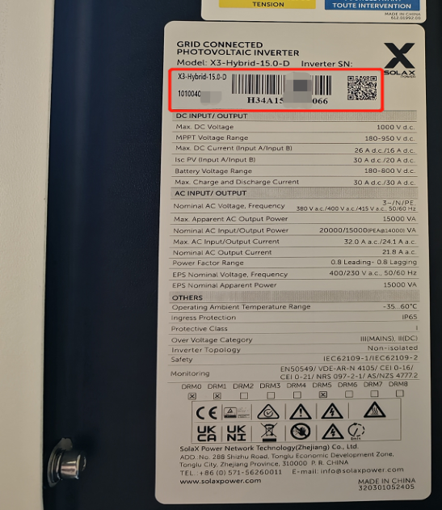
2.[Photo]Battery status light.

3. [Photo]Inverter screen.

4. [Photo]The voltage of each battery.
Voltage of T58 battery | Voltage of T30 battery
 | 
5.[Photo]The voltage of the power cable.
Voltage of T58 battery Power cable | Voltage of T30 battery Power cable
 | 
6.[Video] Whether there is a click when the battery is started.

